**PLAN FOR WEATHER STATION**

**(Insert team members’ names here)**

**(Date)**

**Location:**

We decided to place the weather station on the roof of our college because we found it the most ideal place for the weather station.

* It will be at a distance away from the lake, so that the humidity sensor is not disturbed.
* The height will be good enough so that the air is not blocked by tall building or trees.

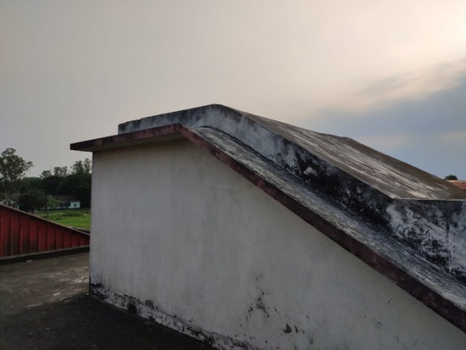 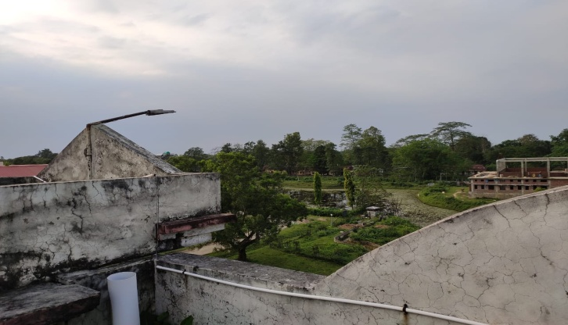

View from top

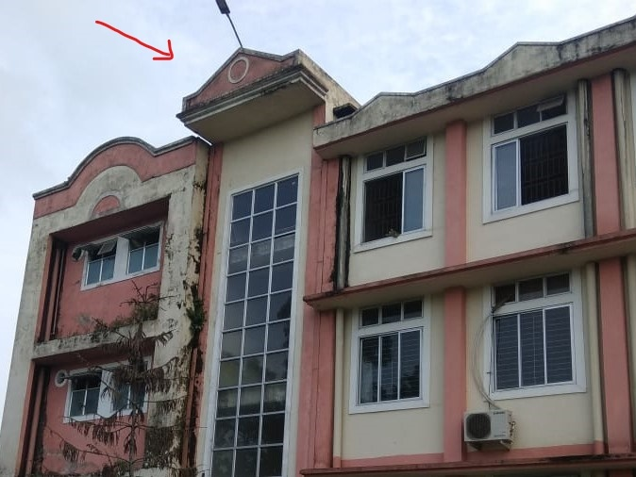

View from bottom

**Power supply:**

We are planning to supply power using solar power.

Materials required:

* TP4056 battery charger
* Voltage booster
* Battery holder
* Solar cell

The solar cell can be connected to the TP 4056 battery charger; we connect the battery charger to the battery. We need a voltage booster to boost the output to get the required voltage. The circuit is given below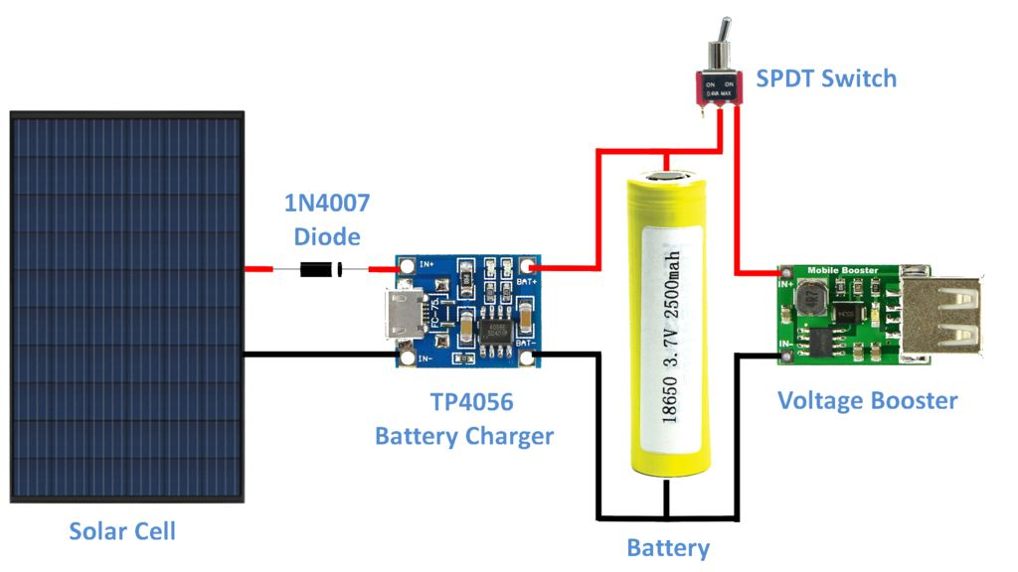

This will need modification as we are not sure how much voltage we will need. Also we will need to find out amount of charge that we can get from the solar cell.

**Sensors:**

We chose few temperature sensor and humidity sensor. We are planning to use one of these sensors. Presently we selected these sensors by comparing them with other sensors for better accuracy. We will have to search more about these sensors before finalising the appropriate one.

1. TMP117 Temperature sensors:

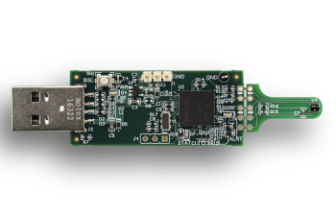

* ±0.1°C (maximum) from –20°C to +50°C
* ±0.15°C (maximum) from –40°C to +70°C
* ±0.2°C (maximum) from –40°C to +100°C
* ±0.25°C (maximum) from –55°C to +125°C
* ±0.3°C (maximum) from –55°C to +150°C
* Operating temperature range: –55°C to +150°C
* Supply range: 1.8 V to 5.5 V

1. HDC1080 Temperature and humidity sensor:

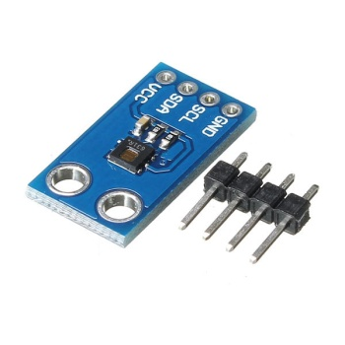

* Relative Humidity Accuracy ±2%
* Temperature Accuracy ±0.2°C
* Supply Voltage 2.7 V to 5.5 V

1. Hall sensor:

A3144 Hall effect Sensor

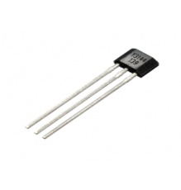

* Operating voltage: 4.5V to 28V (typically 5V)
* Output Current: 25mA
* Can be used to detect both the poles of a magnet
* Operating temperature: -40°C to 85°C

**Wind direction:**

For wind direction we have planned to use rotary encoder. The electrical signal generated by the encoder gives the position of the shaft. So we can use this to program arduino code to give directions. For this we are planning to use

ACE 128 rotary encoder

**Air Quality:**

To check the air quality we are planning to use

MQ 135 gas sensor.

This sensor gives the air quality by sensing the amount of CO2, ammonia, benzene, alcohol etc.

**Material for Anemometer and wind direction vane:**

We will use 3D print for the anemometer and the vane. For the rotary motions bearings will be used.

**Data collection:**

The data will be uploaded in website at real time. We will be using wifi for uploading the data.

We are planning to use Nodemcu esp8266 wifi module.

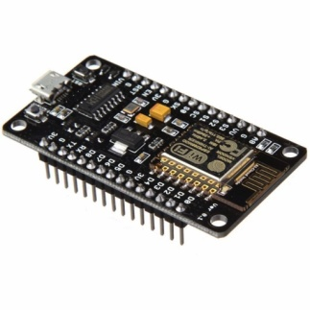

* Memory 128K bytes
* Storage 4M bytes

But the location we chose do not have strong wifi connection, hence we are trying to find an alternative location. If we are unable to find any ideal location like the one we chose earlier we are planning to use Ethernet for uploading data in the website instead of wifi.

For this we will need to use Arduino Ethernet shield.

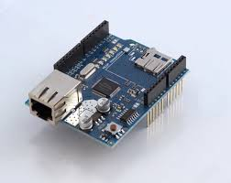

The project plan needs to be rewritten with a breakdown of the sub-projects, as well as the expected timeline and costs. I am providing a suggested structure of how a plan needs to be formulated.

Milestone #0: Establish/choose performance specifications

For instance, what to measure, what probability of data transfer to shoot for, and why?

Milestone #1: Development of a prototype of an environmental monitoring network, with one node in the JEC campus.

Milestone 1.1 prototype development: indoor

The goal is to developme the simplest version of the network, with a Tx and a Rx node, but simplyifying most other aspects. The network will be tested indoors, with both the Tx and Rx (the base station) located indoors, so we do not have to worry about weatherproofing etc.

Milestone 1.1.1 prototype development: indoor: phase 1:

> Tx node: a few simple and low cost sensors on the “environmental sensor” node, based on an Arduino platform, with plug out power (no solar).

> In parallel, you can design and test a rain gauge sensor that will then be integrated with the Tx node.

> Communication: LoRa

> Cost ?

Rx node (base station): Raspberry pi based node that receives data from the Tx node, extracts and time stamps the data, and then pushes to a web server. A viewer from anywhere in the world should be able to view (part of ) the data.

Milestone 1.1.2 prototype development: indoor: phase 2:

> Add the more expensive/complicated sensors. Test again in the indoor setting to verify it meets the target performance metrics.

Milestone 1.2: prototype development: outdoor

Milestone 1.2.1: Add solar power, add weather proofing

(This is far more complicated than it looks. It is easy to protect it from weather and other disturbances that can cause damage (rain, dist, birds, and other critters), but those protection features must not change the values of the environmental varibales that the sensors are measuring. The milestone is to verify that indeed a sensor exposed to the same enviornment provides the “same” reading as the one inside the “node”. The other milestone is testing of data transfer from the Tx sensor node to the website reliably. This is the stage at which you place the Tx sensor node on the JEC roof.)

Milestone 1.3: Design verification

This milestone will be achived if the design has been assessed through on-site testing to establish that it can meet all the performance specifications. You will need to produce the second sensor node, install it in some location in the city, and test to make sure end-to-end performance spec.s meet the requirements established early on.

(Fill out the sub milestones as you see fit)

Milestone #2: Extension of the network to two nodes, with the second node placed somewehere in the Jorhat city.

(Fill out the sub milestones as you see fit)

Milestone #3: Collection of data from both nodes for an extended period (a “few” months) and its analysis to assess the geographical and temporal differences in various environmental variables

(Fill out the sub milestones as you see fit)

Milestone #4: Submit a paper with the results; upload designs to github

Milestone #4.1: Identify an appropriate journal

Finally,

1) you should delineate each team member’s roles and responsibilities.

2) Fix a regular schedule to report on progress (say, last day of every month)